

**LOVELY PROFESSIONAL UNIVERSITY**

**PHAGWARA, PUNJAB**

**FRONTEND DEVELOPMENT**

**REAL ESTATE MANAGEMENT SYSTEM**

**A project report**

**Submitted in partial fulfilment of the requirements for the award of degree of**

**B. Tech**

**Computer science and engineering**

**SUBMITTED BY**

**Name of student: Pentakota Jaswanth**

**Registration number: 12111901**

**Section: K21FZ**

**Roll No.: 38**

**Date of start: 15/9/2023**

**Date of end: 5/11/2023**

**STUDENT DECLARATION**

**To whom so ever it may concern**

I hereby declare that I have completed my Frontend Project on Real Estate Management System from 15/09/2023 to 5/11/2023 under the guidance of Dr. Navneet Kaur. I have declared that I have worked with full dedication during these completion of project and my learning outcomes fulfill the requirements of training for the award of degree of Bachelor of Technology in Computer Science and Technology, Lovely Professional University, Phagwara.

Name of the Student: Pentakota Jaswanth (12111901)

Dated:5/11/2023

**ACKNOWLEDGEMENT**

I express my gratitude to Dr. Navneet Kaur Mam for making the ‘Front-end’ way easier for me by providing adequate facilities, ways, and means by which I was able to complete the project.

I express my sincere gratitude to him for her constant support and valuable suggestions for this course and also for giving more information regarding HTML, CSS, JavaScript, Bootstrap, Jquery, Json, Angular and the importance of front-end development in the IT sector.

Pentakota Jaswanth.

**CLIENT AND DEVELOPER AGREEMENT**

This Client and Developer Agreement ("Real estate management system") is entered into on 20/9/2023, by DSP Infra Developers and between:

[P. Jaya Apparao]

[Pentakota Jaswanth]

[jaswanthpentakota72@gmail.com]

[6304363206]

[Anakapalle, Visakhapatnam, Andhra Pradesh]

[p.jayaapparao@gmail.com]

[9000341807]

[DSP Infra Developers]

**Agreement Details:**

**1. PROJECT DESCRIPTION**

This website is about selling and buying lands. This is a website of **DSP Infra Developers** company. They asked me to make a website which is customer friendly. The company people can easily upload their land details and customers can review it. Customers who visited the website can easily check the land details which are for sales.

**2. PAYMENT**

As this website is non-functional, so we only provide the Proto-type model of original website. We only offer you the cost of my hard work and time. As client want me to appreciate so he is giving me 2000/- as a reward.

**3. TIMELINE**

Project was taken on the date of 25/9/2023 and date of submission was 3/11/2023

IN WITNESS WHEREOF, the Parties hereto have executed this Agreement as of the date first above written.

 

By: Client By: Developer

Name: P. Jaya Apparao Name: Pentakota Jaswanth

Date: 20.9.2023 Date: 20.9.2023

**INTRODUCTION OF THE PROJECT**

Web development is the work involved in developing a website for the Internet. Web development can range from developing a simple single static page of plain text to complex web-based internet applications, electronic businesses, and social network services. There are two broad divisions of web development front-end Development (also called client-side development) and back-end development (also called server-side development).

Front-end development refers to constructing what a user sees when they load a web application - the content, design, and how you interact with it. This is done with three codes HTML, CSS, and JavaScript.

HTML, short for Hyper Text Mark-up Language, is a special code for 'marking up text in order to turn it into a web page. Every web page on the net is written in HTML and it will form the backbone of any web application. CSS, short for Cascading Style sheets, is a code for setting style rules for the appearance of web pages. CSS handles the Cosmetic side of the web. Finally, JavaScript is a scripting language that's widely used to add functionality and interactivity to web pages.

Back-end development controls what goes on behind the scenes of a web application. A back-end often uses a database to generate the front-end. Back-end scripts are written in many different coding languages and frameworks, such as …

* PHP
* Ruby and Rails
* ASP.NET
* Perl
* Java
* Node.js
* Python

But I have just done the training in only one of the two web development divisions i.e., “FRONT-END DEVELOPMENT”. Because I thought that mastering front-end development first can help you understand how websites are built and how to improve their performance behind the scenes.

**REQUIREMENTS:**

**Basic Hardware and Software Requirements**

Operating System:

* Windows 7, windows 8 or windows 10
* Mac OSX 10.8, 10.9, 10.10, 10.11

Hardware:

* Processor with 2 GHz frequency or above
* A minimum of 2GB of RAM
* Monitor Resolution 1024 x 768 or higher
* A minimum of 20GB of available space on the hard disk

Browsers:

* Chrome*36+
* Edge* 20+
* Mozilla Firefox 31+
* Internet Explorer 11+ (windows only)

Safari 6+ (Mac OS only)

**INTRODUCTION OF THE PROJECT UNDERTAKEN**

**Technology/Language/Modules learnt:**

I learnt front-end development from Board infinity’s summer training program. I learned these technologies during the six weeks training period:

* HTML
* CSS
* JAVASCRIPT
* BOOTSTRAP
* JQUERY
* ANGULAR

There is a lot more to say about it. The web site is actually laid out in three fundamental layers,

namely:

1. **Structure Layer:** We use HTML to give structure and semantic meaning to the content.

2. **Presentation Layer:** Use CSS to give a layout and visual presentation to the content.

3. **Behavior Layer:** Use JavaScript to give additional interaction to the website.

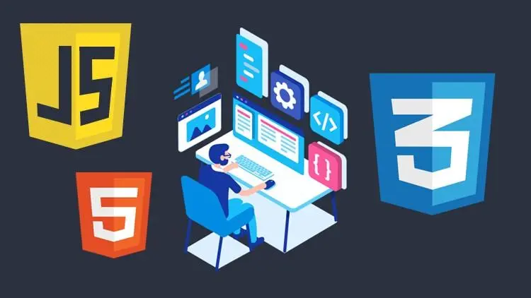

**HTML:**

HTML is an acronym that stands for "Hyper Text Markup Language" which is used for creating web pages and web applications.

In the late 1980s, a physicist, Tim Berners-Lee who was a contractor at CERN, proposed a system for CERN researchers. In 1989, he wrote a memo proposing an internet-based hypertext system.

**Tim Berners-Lee** is known as the father of HTML. The first available description of IITML was a document called "HTML Tags" proposed by Tim in late 1991 The latest version of HTML is HTML5. Let's see what is meant by Hypertext Markup Language, and Web page.

**Hypertext**: Hypertext simply means "Text within Text." A text that has a link within it, is a hypertext. Whenever you click on a link that brings you to a new webpage, you have clicked on a hypertext. Hypertext is a way to link two or more web pages (HTML documents) with each other.

**Markup language**: A markup language is a computer language that is used to apply layout and formatting conventions to a text document. Markup language makes text more interactive and dynamic. It can turn text into images, tables, links, etc.

**Web page:** A web page or webpage is a document, commonly written in HTML, that is viewed in an Internet browser. A web page can be accessed by entering a URL address into a browser's address bar. A web page may contain text, graphics, and hyperlinks to other web pages and files.

A web page provides information to viewers, including pictures or videos to help illustrate important topics. A web page may also be used as a method to sell products or services to viewers. Multiple web pages make up a website, like our Computer Hope website.

**CSS**

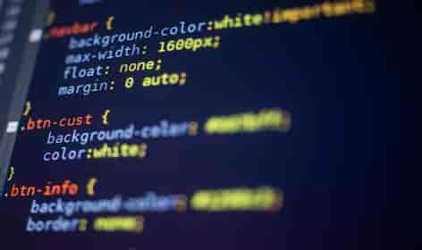

CSS stands for Cascading Style Sheet CSS is used to design HTML tags.CSS is a widely used language on the web. HTML, CSS, and JavaScript are used for web designing. It helps web designers to apply style on HTML tags. CSS is used to define styles for your web pages, including the design, layout, and variations in display for different devices and screen sizes. SGML (Standard Generalized Markup Language) is the origin of CSS. It is a language that defines markup languages.

CSS handles the look and feel part of a web page. Using CSS, you can control the color of the text, the style of fonts, the spacing between paragraphs, how columns are sized and laid out, what background images or colors are used, layout designs, and variations in display for different devices and screen sizes as well as a variety of other effects.

CSS is easy to learn and understand but it provides powerful control over the presentation of an HTML document. Most commonly, CSS is combined with the markup languages HTML or XHTML. There are many advantages of web development.

You can write CSS once and then reuse the same sheet in multiple HTML pages. You can define a style for each HTML element and apply it to as many Web pages as you want. To make a global change, simply change the style, and all elements in all the web pages will be updated automatically.

CSS can be used to style HTML elements in three ways:

1. **Inline**: CSS rule applied as an attribute to the HTML element. Has the most precedence.
2. **Internal**: Many CSS rules can be written inside the same HTML file for elements. It has less precedence than the above one.
3. **External**: CSS rules are written in a separate file and then linked to the respective HTML file. Has less precedence.

**Advantages of CSS:**

**CSS saves time** - you can write CSS once and then reuse the same sheet in multiple HTML pages. You can define a style for each HTML element and apply it to as many Web pages as you want.

**Pages load faster** -If you are using CSS, you do not need to write HTML tag attributes every time. Just write one CSS rule of a tag and apply it to all the occurrences of that tag. So less code means faster download times.

**Easy maintenance** - To make a global change, simply change the style, and all elements in all the web pages will be updated automatically.

**Superior styles to HTML** - CSS has a much wider array of attributes than HTML, so you can give a far better look to your HTML page in comparison to HTML attributes.

**Multiple Device Compatibility** - Style sheets allow content to be optimized for more than one type of device. By using the same HTML document, different versions of a website can be presented for handheld devices such as PDAs and cell phones or for printing.

**Global web standards** - Now HTML attributes are being deprecated and it is being recommended to use CSS. So, it's a good idea to start using CSS in all the HTML pages to make them compatible to future browsers.

**Limitations of CSS:**

* Ascending by selectors is not possible
* Limitations of vertical control
* No expressions
* No column declaration
* Pseudo-class not controlled by dynamic behavior
* Rules, styles, and targeting specific text not possible

CSS frameworks are the pre-planned libraries that make easy and more standard-compliant web page styling. The frequently used CSS framework is Bootstrap which I have learned in this training.

**JAVASCRIPT:**

JavaScript is a scripting or programming language that allows you to implement complex features on web pages — every time a web page does more than just sit there and display static information for you to look at — displaying timely content updates, interactive maps, animated 2D/3D graphics, scrolling video jukeboxes, etc. — you can bet that JavaScript is probably involved. It is the third layer of the layer cake of standard web technologies, two of which (HTML and CSS) we have covered in much more detail in other parts of the Learning Area.

The core client-side JavaScript language consists of some common programming features that allow you to do things like:

* Store useful values inside variables
* Operations on pieces of text (known as "strings" in programming.
* Running code in response to certain events occurring on a web page. We used a click event in our example above to detect when the label is clicked and then run the code that updates the text label.



What is even more exciting however is the functionality built on top of the client-side JavaScript language. So-called Application Programming Interfaces (APIs) provide you with extra superpowers to use in your JavaScript code.APIs are ready-made sets of code building blocks that allow a developer to implement programs that would otherwise be hard or impossible to implement. They do the same thing for programming that ready-made furniture kits do for home building — it is much easier to take ready-cut panels and screw them together to make a bookshelf than it is to work out the design yourself, go and find the correct wood, cut all the panels to the right size and shape, find the correct-sized screws, and then put them together to make a bookshelf.

**BOOTSTRAP:**

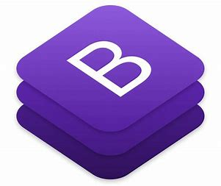

Bootstrap is an open-source JavaScript framework developed by the team at Twitter. They Used HTML CSS JS for building user-defined interface! We can say it "Front-end- framework".

Bootstrap is a CSS based framework used to make websites responsive. The Purpose of bootstrap is to make faster responsive websites, which will adjust itself on all devices like Mobile phones, tablets, computer, Laptops and all. Bootstrap is the world's most popular front end framework to develop mobile first, responsive website very easily. It is very easy to get started with, it is highly customizable, and you can develop websites very quickly. The Bootstrap community is pretty huge as well.

Earlier whenever we are writing CSS we used to define all the properties in the separate CSS file that we want to attach the separate CSS file, wherein bootstrap they have already written some classes in the bootstrap.css file. You just have to import that CSS file and use their classes.

In addition, Bootstrap requires Jquery to work. Jquery is a popular and widely used JavaScript library which both simplifies and adds JavaScript cross-browser compatibility.

Bootstrap can be boiled down to three main files:

* Bootstrap.css a CSS framework
* Bootstrap.js-a JavaScript/Jquery framework
* Glyphicons - a font (an icon font set)

In addition, Bootstrap requires Jquery to work. Jquery is a popular and widely used JavaScript library that both simplifies and adds JavaScript cross-browser compatibility.

**Advantages of Bootstrap**

The biggest advantage of using Bootstrap is that comes with free set of tools for creating flexible and responsive web layouts well as common interface components. Here are some more advantages, why one should opt for Bootstrap:

**Save lots of time** - you can save lots of time and efforts using the Bootstrap ined design templates and classes and concentrate on other development work.

**Responsive features** - Using Bootstrap you can easily create responsive designs. Bootstrap responsive features make your web pages appear more appropriately on different devices and screen resolutions without any change in markup.

**Consistent design**- All Bootstrap components share the same design templates and styles through a central library, so that the designs and layouts of your web pages are consistent throughout your development.

**Easy to use**- Bootstrap is very easy to use. Anybody with a basic working knowledge of HTML and CSS can start development with Bootstrap.

**Compatible with browsers** - Bootstrap is created with modern browsers in mind and it is compatible with all modern browsers such as Mozilla Firefox, Google Chrome, Safari, Internet Explorer, and Opera.

**Open Source**- And the best part is, it is completely free to download and use

**Future Scope**

Front-end developers are vital to creating a company’s online presence. Because of this, many companies choose to turn to experts at outsourcing firms.

Front-end developers and organizations constantly look for solutions to improve user experience, scalability, and accessibility. In 2023, advanced AI/ML will be developed in front-end development. As online products become increasingly integrated into daily life, AR & VR are becoming more popular daily.

**JQUERY:**

jQuery is a lightweight, open-source JavaScript library that has played a pivotal role in web development since its release in 2006. Developed with the primary goal of simplifying and enhancing the way developers interact with HTML documents, jQuery has become an indispensable tool for building interactive and dynamic web applications. In this short essay, we will explore the origins, key features, and the enduring significance of jQuery in the world of web development.

Origins and Key Features

jQuery was created by John Resig, who aimed to streamline the process of handling HTML documents, managing event handling, and simplifying AJAX (Asynchronous JavaScript and XML) requests. Here are some of its key features:

1. DOM Manipulation: jQuery greatly simplifies the manipulation of the Document Object Model (DOM), allowing developers to select, traverse, and modify HTML elements with ease. The library provides concise and versatile methods for interacting with web page elements.
2. Event Handling: jQuery streamlines event handling by enabling developers to attach event listeners to HTML elements and respond to user interactions, such as clicks, mouse movements, and keyboard inputs.
3. Animation and Effects: jQuery provides a range of animation and effects functions, making it simple to create smooth transitions, animations, and visual enhancements in web applications.
4. AJAX: Asynchronous requests are crucial for fetching data from a server without having to refresh the entire web page. jQuery simplifies AJAX calls with functions like $. ajax(), making it easier to load data dynamically.
5. Cross-Browser Compatibility: jQuery abstracts the differences between various web browsers, ensuring consistent behaviour and functionality across different platforms, which was a significant challenge for web developers in the past.

**Significance in Web Development**

1. Cross-Browser Compatibility: In the early days of web development, cross-browser compatibility was a substantial headache. jQuery's ability to standardize interactions across different browsers made it a go-to choice for developers, reducing the need for browser-specific workarounds.
2. Increased Productivity: jQuery's concise and intuitive syntax allows developers to write less code while achieving more. This increase in productivity has saved countless hours of development time.
3. Rich User Interfaces: With its easy-to-use animation and effects functions, jQuery empowered developers to create rich and interactive user interfaces, greatly enhancing the user experience on websites and web applications.
4. Extensibility: jQuery's extensibility through plugins has fostered a thriving ecosystem of third-party libraries and extensions, covering a wide range of functionalities, from sliders and carousels to complex data visualization.
5. Learning Curve: jQuery's relatively gentle learning curve, especially for those familiar with JavaScript, has made it accessible to a broad audience of developers, from beginners to experts.
6. Legacy and Transition: While newer JavaScript frameworks and libraries have emerged, jQuery's legacy is notable. Many websites and applications still rely on jQuery, and it has served as a stepping stone for developers looking to transition to more modern technologies.

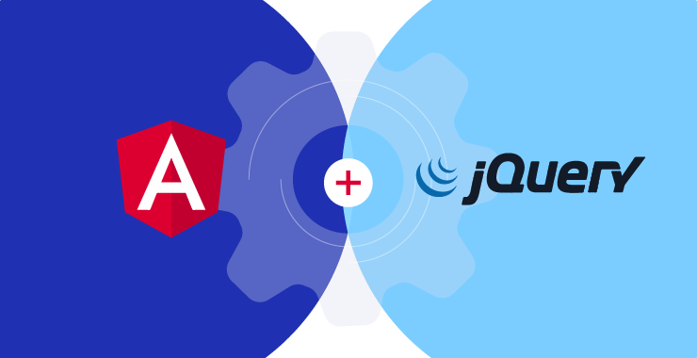

**ANGULAR:**

Angular is a popular and powerful open-source framework for web development, widely used for creating dynamic, single-page applications (SPAs) and modern web applications. Developed and maintained by Google, Angular has evolved significantly since its inception, providing developers with a comprehensive toolset for building robust, scalable, and maintainable web applications. In this essay, we will explore the key features, benefits, and components of Angular that make it a go-to choice for many developers.

**Key Features of Angular**

1. Component-Based Architecture: Angular follows a component-based architecture, where applications are built by composing reusable and encapsulated components. This modular approach makes it easier to develop and maintain complex applications, as each component focuses on a specific aspect of the user interface or functionality.
2. Two-Way Data Binding: Angular provides two-way data binding, a feature that synchronizes the model and view. This means that changes in the model automatically update the view, and changes in the view also update the model, reducing the need for manual DOM manipulation and improving code clarity.
3. Dependency Injection: Angular's dependency injection system allows developers to manage the dependencies of their application in a clean and organized manner. This promotes code reusability and maintainability, as components can be easily replaced or updated without affecting other parts of the application.
4. Directives: Angular offers a range of directives that extend HTML with additional functionality. These directives allow developers to create dynamic and interactive user interfaces. Notable directives include ngIf, ngFor, and ngClass.
5. Routing: Angular provides a robust routing system that allows developers to create client-side navigation and build SPAs. This feature enhances the user experience by enabling seamless transitions between different views and maintaining the browser's history.

**Benefits of Using Angular**

1. Productivity: Angular offers a comprehensive set of tools and features, reducing the need for developers to write boilerplate code. This leads to increased productivity and quicker development cycles.
2. Maintainability: The modular and component-based structure of Angular makes it easier to manage and maintain large applications, as changes in one component have minimal impact on others.
3. Performance: Angular's powerful change detection mechanism and Ahead-of-Time (AOT) compilation help optimize application performance, resulting in faster load times and smooth user experiences.
4. Community and Ecosystem: Angular has a vibrant and supportive community, offering a wealth of resources, libraries, and plugins that can enhance the development process.
5. Cross-Platform Development: Angular allows developers to build not only web applications but also mobile and desktop applications using technologies like Angular NativeScript and Angular Electron.

**Components of Angular**

**Angular consists of several key components:**

1. Angular CLI: The Command Line Interface for Angular, which provides commands to generate, build, test, and deploy Angular applications.
2. Modules: Angular applications are organized into modules, which encapsulate related components, services, and other application logic.
3. Components: The building blocks of an Angular application, responsible for rendering views and handling user interactions.
4. Services: Reusable and injectable services that provide business logic, data, and functionality to components.
5. Templates: HTML templates that define the structure and layout of a component's view.
6. Directives: HTML extensions that add dynamic behaviour to elements in the view.

**REAL ESTATE MANAGEMENT SYSTEM**

**PROJECT DETAILS:**

This website is about selling and buying lands. This is a website of **DSP Infra Developers** company. They asked me to make a website which is customer friendly. The company people can easily upload their land details and customers can review it. Customers who visited the website can easily check the land details which are for sales.

**Requirements of customer:**

**Functional Requirements:**

Functional requirements for a Land Broker Website are the specific features and capabilities that the system must have to fulfil its intended purpose. These requirements help define the functionality and behaviour of the website. Here are some functional requirements for a Land Broker Website:

1. User Registration and Authentication:
   * Users can create accounts with unique usernames and passwords.
   * Users must provide valid email addresses for account verification.
   * Users can log in securely with their credentials.
   * Password reset and account recovery options are available.
2. User Roles:
   * User roles include land brokers, landowners, and potential buyers, each with distinct privileges and capabilities.
3. Property Listings:
   * Land brokers can create property listings with details such as title, description, location, size, price, and images.
   * Property listings must be categorized by property type (e.g., residential, commercial, agricultural).
4. Property Details:
   * Users can view property details, including a detailed description, images, property features, and contact information for the broker.
   * Property locations are displayed on a map for geospatial reference.
5. Communication:
   * Users can send inquiries and messages to brokers or property listers.
   * Real-time notifications for new messages and updates.
   * Users can request property viewings and schedule appointments.
6. Payment Integration:
   * Integration with a secure payment gateway to support premium listings and advertising options.
   * Users can make secure online payments for various services, such as featured listings.
7. Reviews and Ratings:
   * Users can leave reviews and ratings for brokers and properties.
   * Ratings can be based on user experience, property condition, and broker professionalism.
8. Notifications:
   * Users receive notifications for new property listings, messages, inquiries, and updates related to their activities on the platform.
   * Email notifications for important events, such as account verification and password reset.
9. Mobile Responsiveness:
   * The website should be responsive and accessible on various devices, including smartphones, tablets, and desktops.

These functional requirements are essential for the effective operation of a Land Broker Website, providing users with the tools and features they need to search for, list, and transact land properties while ensuring a secure and user-friendly experience. Additional features and requirements may be necessary based on the specific goals and needs of the website.

**Data Flow Diagram(DFD):**

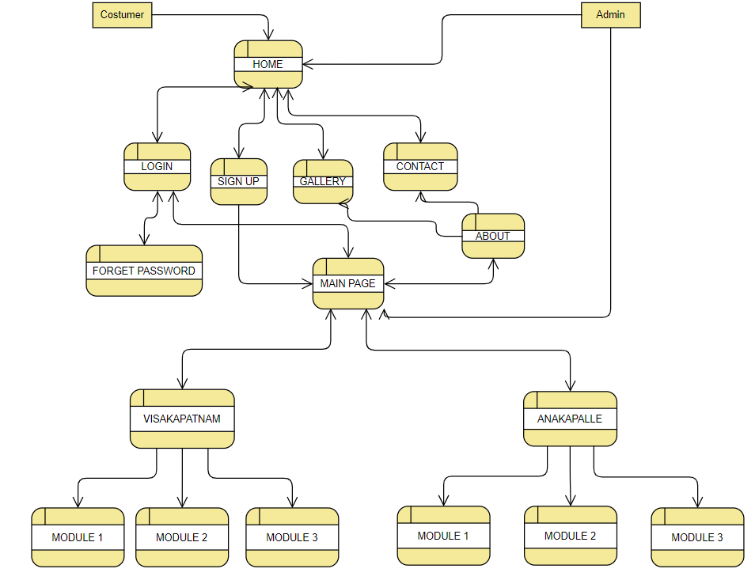

**PROJECT OUT-PUT:**

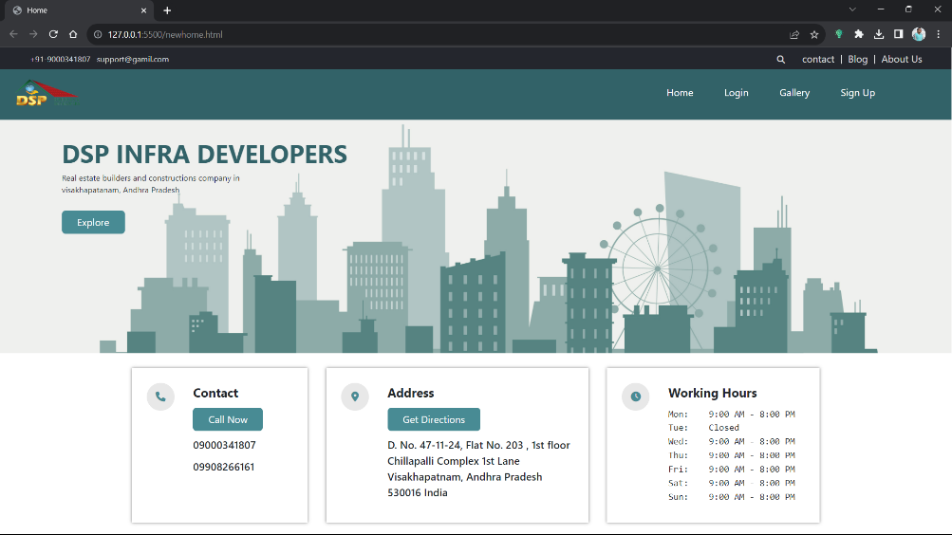

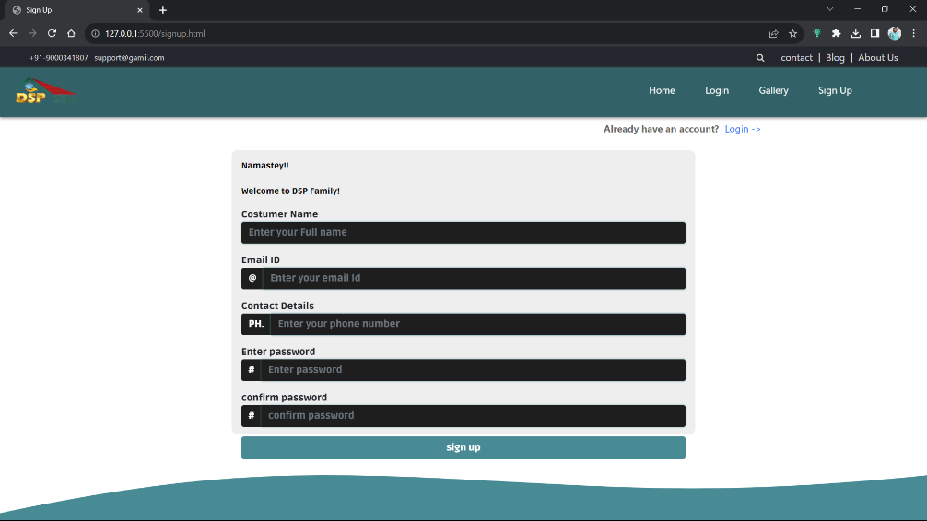

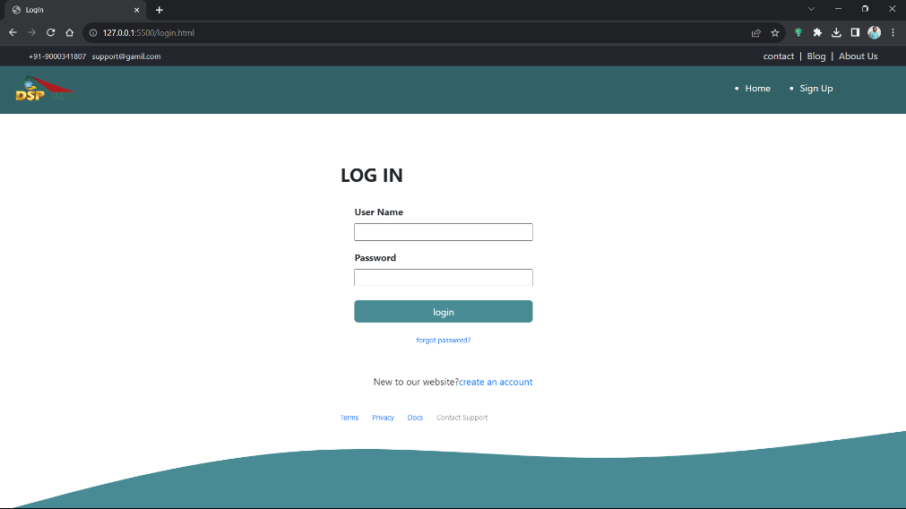

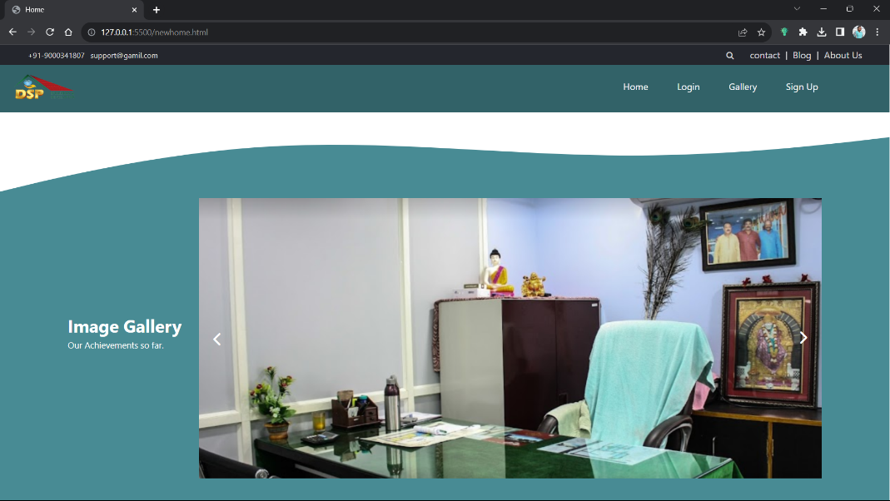

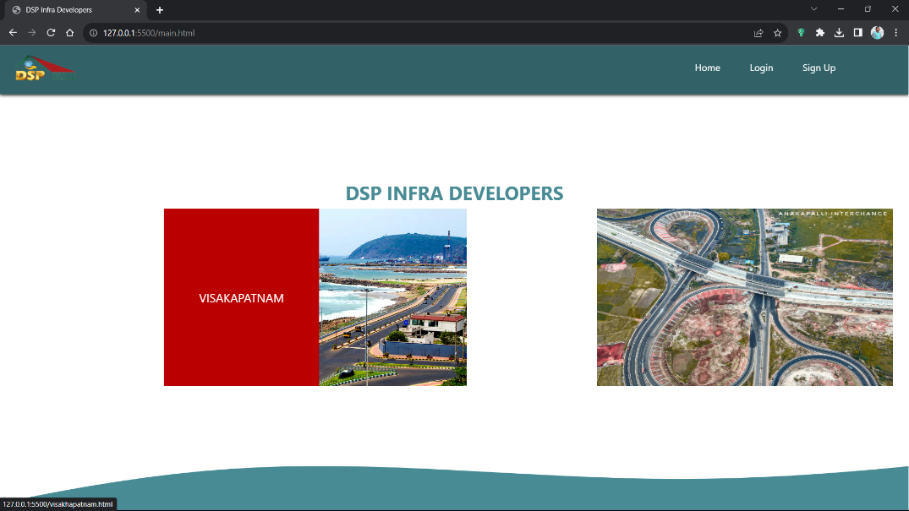

**LEARNING OUTCOMES:**

From this training of 6 weeks which we underwent in our summer vacation I learned to develop front-end web pages using html, CSS and Bootstrap. This technology will help me in my future in getting job and I will be able to create responsive web pages.

The web is regularly evolving and developing, serving the population throughout the world. Many people are wondering what the web development future will bring. Similarly, with many predictions (sources), we are just able to find the indications and future trends of web development that can help to point us in the right direction. Some of these trends are an update to a previous trend which expels all its drawbacks while some are totally new to the field. Through this training I have learnt

* New technologies like HTML, CSS, JS, Bootstrap and Angular.
* How to make tables in HTML and its attributes?
* How to use HTML5 lists, image and progress tags for building elements
* How to build a product listing page?
* How to build a product landing page?
* About responsive web pages
* Designing of the web pages
* HTML Fundamentals: Students should learn how to structure web content using HTML (Hypertext Markup Language), including creating semantic elements, understanding HTML5 features, and organizing content effectively.
* CSS Styling: Students should gain proficiency in applying CSS (Cascading Style Sheets) for styling web pages. This includes understanding selectors, properties, values, layout techniques, and responsive design principles
* Responsive Design: Learners should understand the principles of responsive design and be able to create web interfaces that adapt well to different screen sizes and devices, using techniques like media queries and flexible layouts.
* Typography and Color: Students should grasp the importance of typography and color in web design, and learn how to choose appropriate fonts, sizes, and color schemes to enhance the overall user experience.
* Basic JavaScript: An introduction to JavaScript programming is often included, covering concepts like variables, data types, functions, and basic programming logic. This provides a foundation for adding interactivity to web pages.
* DOM Manipulation: Students should learn how to interact with the Document Object Model (DOM) using JavaScript, allowing them to create dynamic and interactive elements on web pages.
* Introduction to Frameworks and Libraries: Depending on the course, students might get an overview of popular front-end frameworks and libraries like React, Angular, or Vue.js. They might not become experts but should understand their purposes and how to use them.

**CONCLUSION**

n conclusion, a Real Estate Management System (REMS) website represents a fundamental transformation in how real estate professionals and property owners manage their properties, streamline operations, and provide enhanced services to clients. This web-based platform leverages technology to address the complex challenges of the real estate industry, offering a wide range of functionalities for property listing, management, and transaction processing.

Throughout this hypothetical scenario, we have explored the various components, features, and requirements of a REMS website, both functional and non-functional. The system's functional requirements encompass core capabilities such as property listing, user management, financial tracking, document storage, and reporting. These features enable real estate professionals to efficiently manage their property portfolios, provide transparent services to clients, and optimize their operations.

**REFERENCES**

I referred JavaScript functions and classes from w3school for better understanding.

https://www.w3schools.com/js/default.asp

for solving the challenges, I faced I referred stack Overflow.

https://stackoverflow.com/

for video solutions I referred YouTube.

https://www.youtube.com/